**Ankur Acharjee**

Chandigarh university

Doorbell using arduino

**EXP: DOORBELL USING BUZZER AND ARDUINO**

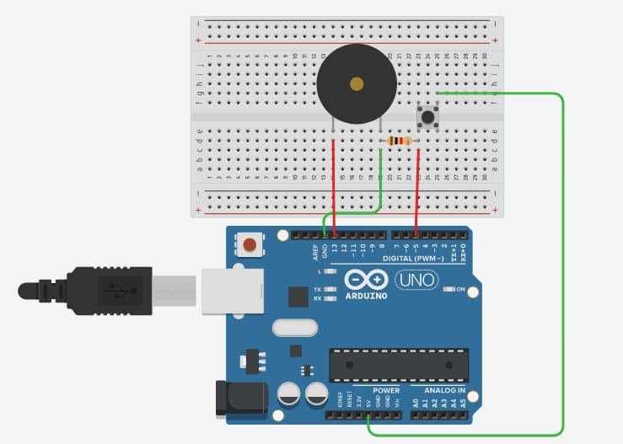

***Concept Used: -***

A circuit is made in which 2 digital pins are used where a pin (say 7) is

connected to a buzzer which is further connected to ground. Now another pin

(say 12) is connected to switch. One end of the switch is connected to 5V

supply and intersection of pin 12 and switch is connected to resistor which is

connected to ground from another end. Value of resistance is very high. The

resistors are used to resist the flow of current. Coding is done in such a way that

when switch is pressed for the 1st time buzzer starts buzzing and again when the switch is pressed the 2nd time buzzer stops buzzing.

***Learning and Observations: -***

• Making circuits using Arduino.

• Connecting buzzer and switch with Arduino.

• Ground has least resistance.

• Working of Arduino UNO.

• Coding to be done on Arduino.exe for stimulation of the experiment.

***Problems & Troubleshooting****: -*

1. To check the flow of current in the circuit.
2. To check whether the buzzer is operable or not.

***Precautions: -***

1. The circuit made can be wrong.

2. Any Element used may be defective.

3. The coding done can be incorrect due to which stimulation can be failed.

4. Port Selection for Arduino can be incorrect due to which it won’t upload on

Arduino Board and resulting in failure of experiment.

***Learning Outcomes: –***

1. Setting up circuit on a Arduino.

2. Connecting switch, buzzer and Arduino.

3. Using switch and buzzer.

4. Working and coding of Arduino.

***Result: –***

Working of buzzer and switch verified after uploading the program. Doorbell is

ready to ring.